Lecture 04: Probability and Inference

Bill Perry

# **Lecture 4: Probability and Statistical Inference**

* Review of probability distributions
* Standard normal distribution and Z-scores
* Standard error and confidence intervals
* Statistical inference fundamentals
* Hypothesis testing principles

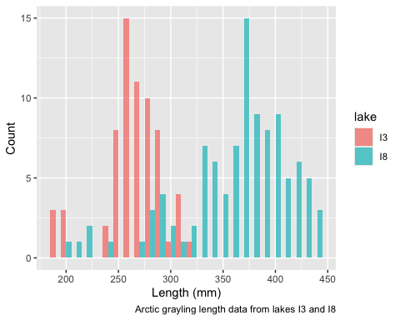

|  |
| --- |
| Practice Exercise 1: Exploring the Grayling Dataset |
| Let’s explore the Arctic grayling data from lakes I3 and I8. Use the grayling_df data frame to create basic summary statistics.  # Write your code here to explore the basic structure of the data # also note plottig a box plot is really useful str(grayling_df)  spc_tbl_ [168 × 5] (S3: spec_tbl_df/tbl_df/tbl/data.frame)  $ site : num [1:168] 113 113 113 113 113 113 113 113 113 113 ...  $ lake : chr [1:168] "I3" "I3" "I3" "I3" ...  $ species : chr [1:168] "arctic grayling" "arctic grayling" "arctic grayling" "arctic grayling" ...  $ total_length_mm: num [1:168] 266 290 262 275 240 265 265 253 246 203 ...  $ mass_g : num [1:168] 135 185 145 160 105 145 150 130 130 71 ...  - attr(*, "spec")=  .. cols(  .. site = col_double(),  .. lake = col_character(),  .. species = col_character(),  .. total_length_mm = col_double(),  .. mass_g = col_double()  .. )  - attr(*, "problems")=<externalptr>  summary(grayling_df)  site lake species total_length_mm  Min. :113 Length:168 Length:168 Min. :191.0   1st Qu.:113 Class :character Class :character 1st Qu.:270.8   Median :118 Mode :character Mode :character Median :324.5   Mean :116 Mean :324.5   3rd Qu.:118 3rd Qu.:377.0   Max. :118 Max. :440.0     mass_g   Min. : 53.0   1st Qu.:151.2   Median :340.0   Mean :351.2   3rd Qu.:519.5   Max. :889.0   NA's :2 |

# **Lecture 4:** Probability Distributions

## Probability Distribution Functions

* A **probability distribution** describes the probability of different outcomes in an experiment
* We’ve seen histograms of observed data
* Theoretical distributions help us model and understand real-world data
* We will focus on a standard normal distribution and a t distribution

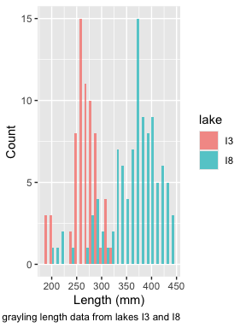

# **Lecture 4:** The Standard Normal Distribution

The standard normal distribution is crucial for understanding statistical inference:

* Has mean (μ) = 0 and standard deviation (σ) = 1
* Symmetrical bell-shaped curve
* Area under the curve = 1 (total probability)
* Approximately:
  + 68% of data within ±1σ of the mean
  + **95% of data within ±2σ of the mean - really 1.96σ**
  + 99.7% of data within ±3σ of the mean

Z-scores allow us to convert any normal distribution to the standard normal distribution.

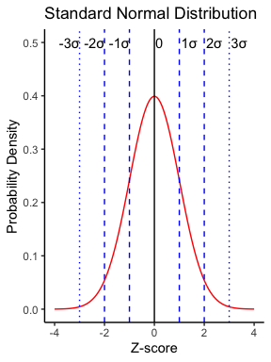

|  |
| --- |
| Practice Exercise 2: Calculating Z-scores |
| Let’s practice converting raw values to Z-scores using the Arctic grayling data.  # Calculate the mean and standard deviation of fish lengths mean_length <- mean(grayling_df$total_length_mm, na.rm = TRUE) sd_length <- sd(grayling_df$total_length_mm, na.rm = TRUE)  # Calculate Z-scores for fish lengths grayling_df <- grayling_df %>%  mutate(z_score = (total_length_mm - mean_length) / sd_length)  # View the first few rows with Z-scores head(grayling_df)  # A tibble: 6 × 6  site lake species total_length_mm mass_g z_score  <dbl> <chr> <chr> <dbl> <dbl> <dbl> 1 113 I3 arctic grayling 266 135 -0.900 2 113 I3 arctic grayling 290 185 -0.531 3 113 I3 arctic grayling 262 145 -0.961 4 113 I3 arctic grayling 275 160 -0.761 5 113 I3 arctic grayling 240 105 -1.30  6 113 I3 arctic grayling 265 145 -0.915 |

# What proportion of fish are within 1 standard deviation of the mean?  
within_1sd <- sum(abs(grayling_df$z_score) <= 1, na.rm = TRUE) / sum(!is.na(grayling_df$z_score))  
cat("Proportion within 1 SD:", round(within_1sd * 100, 1), "%\n")

Proportion within 1 SD: 64.3 %

# Lecuture 4: Standard normal distribution

You want to know things about this population like

* probability of afish having a certain length (e.g., > 300 mm)
* Can solve this by integrating under curve
* But it is tedious to do every time
* Instead
  + we can use the *standard normal distribution* (SND)

# A tibble: 1 × 1  
 mean_length  
 <dbl>  
1 266.

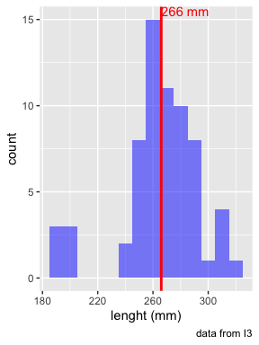

# Lecture 4: Standard normal distribution

Standard Normal Distribution

* “benchmark” normal distribution with µ = 0, σ = 1
* The Standard Normal Distribution is defined so that:
  + ~68% of the curve area within +/- 1 σ of the mean,
  + ~95% within +/- 2 σ of the mean,
  + ~99.7% within +/- 3 σ of the mean

*remember σ = standard deviation

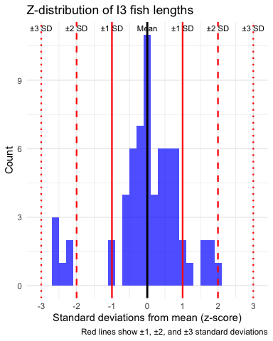

# Lecture 4: Standard normal distribution

Areas under curve of Standard Normal Distribution

* Have been calculated for a range of sample sizes
* Can be looked up in z-table
* No need to integrate
* Any normally distributed data can be standardized
  + transformed into the standard normal distribution
  + a value can ber looked up in a table



# Lecture 4: Standard normal distribution

Done by converting original data points to z-scores

* Z-scores calculated as:

* z = z-score for observation
* xi = original observation
* µ = mean of data distribution
* σ = SD of data distribution

So lets do this for a fish that is 300mm long and guess the probability of catching something larger

z = (300 - 265.61)/28.3 = 1.215194

i3_stats <- gray_i3_df %>%  
 summarize(  
 mean_length = round(mean(total_length_mm, na.rm = TRUE), 2),  
 sd_length = sd(total_length_mm, na.rm = TRUE),  
 n = sum(!is.na(total_length_mm)),  
 se_length = round(sd_length / sqrt(sum(!is.na(total_length_mm))), 2),  
 .groups = "drop"  
 )  
  
# Display the results  
i3_stats

# A tibble: 1 × 4  
 mean_length sd_length n se_length  
 <dbl> <dbl> <int> <dbl>  
1 266. 28.3 66 3.48

# Lecture 4: Standard normal distribution

Done by converting original data points to z-scores

* Z-scores calculated as:

* z = z-score for observation
* xi = original observation
* µ = mean of data distribution
* σ = SD of data distribution

So lets do this for a fish that is 320mm long and guess the probability of catching something larger

z = (320 - 265.61)/28.3 = 1.92

or .9726 in table or 97.3% is the area left of the curve and

100 - 97.3 = 2.7% or 2.7% of fish are expected to be longer

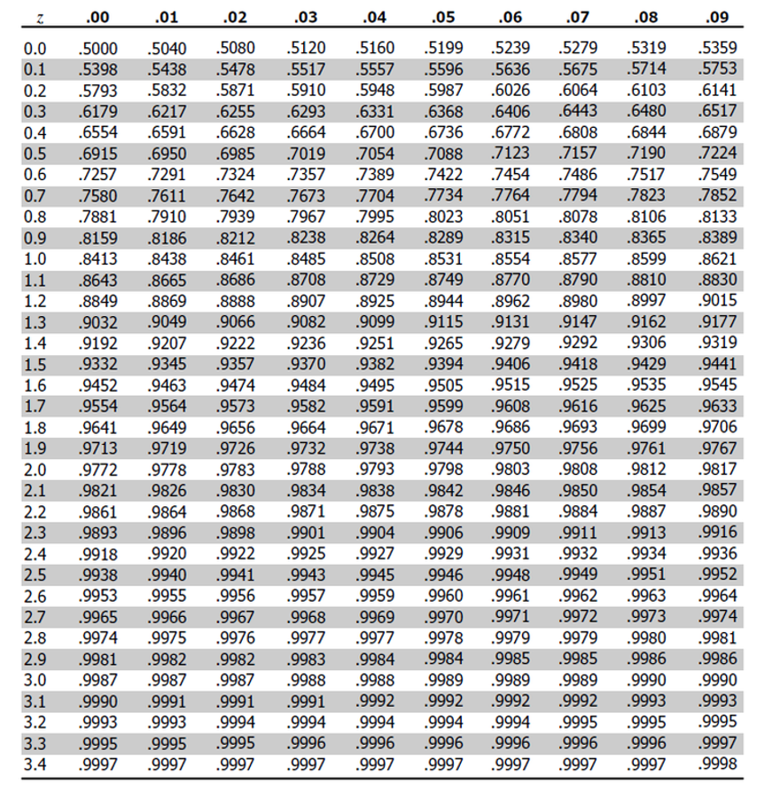

# **Lecture 4:** Sampling a population - Std Error

The **standard error of the mean (SEM)** tells us how precise our sample mean is as an estimate of the population mean.

Standard Error Formula:

Where:

* is the sample standard deviation
* is the sample size

**Key properties:**

* SEM decreases as sample size increases
* SEM is used to construct confidence intervals
* SEM measures the precision of the sample mean

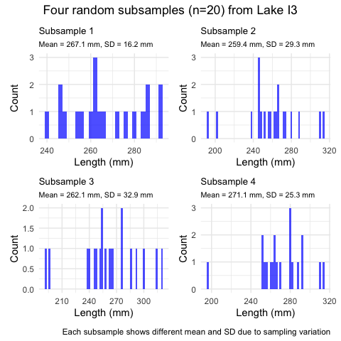

|  |
| --- |
| Practice Exercise 5: Sampling Distributions |
| Let’s explore how sample size affects our estimates by taking samples of different sizes:  # Set seed for reproducibility set.seed(456)  # Create samples of different sizes small_sample <- grayling_df %>% sample_n(5) medium_sample <- grayling_df %>% sample_n(30) large_sample <- grayling_df %>% sample_n(125)  # Calculate mean and standard error for each sample small_mean <- mean(small_sample$total_length_mm, na.rm = TRUE) small_se <- sd(small_sample$total_length_mm, na.rm = TRUE) / sqrt(10)  medium_mean <- mean(medium_sample$total_length_mm, na.rm = TRUE) medium_se <- sd(medium_sample$total_length_mm, na.rm = TRUE) / sqrt(30)  large_mean <- mean(large_sample$total_length_mm, na.rm = TRUE) large_se <- sd(large_sample$total_length_mm, na.rm = TRUE) / sqrt(100)  # Create a data frame with the results results <- data.frame(  Sample_Size = c(10, 30, 100),  Mean = c(small_mean, medium_mean, large_mean),  SE = c(small_se, medium_se, large_se) )  # Display the results results  Sample_Size Mean SE 1 10 302.000 26.607330 2 30 319.200 12.082989 3 100 323.328 6.478149  What do you observe about the standard error as sample size increases? Why does this happen? |

# **Lecture 4:** Estimating µ - population mean

## Every sample gives slightly different estimate of µ

* Can take many samples and calculate means
* Plot the frequency distribution of means
* Get the “sampling distribution of means”

## 3 important properties:

* Sampling distribution of means (SDM) from normal population will be normal
* Large Sampling distribution of means from any population will be normal (Central Limit Theorem)
* The mean of Sampling distribution of means will equal µ or the mean

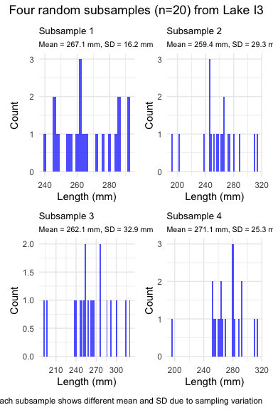

# **Lecture 4:** Estimating µ - population mean

## Given above

* can estimate the standard deviation of sample means
* “Standard error of sample mean”
* How good is your estimate of population mean? (based on the sample collected)
* quantifies how much the sample means are expected to vary from samples
* gives an estimate of the error associated with using $\overset{‾}{y}$ to estimate $μ$…



# **Lecture 4:** Estimating µ - population mean

Notice: - $s_{\overset{‾}{y}}$ depends on - sample s (standard deviation) - sample n - ($s_{\overset{‾}{y}}=\frac{s}{\sqrt{n}}$)

How and why? - Decreases with sample n - number - increases with sample s - standard deviation

* Large sample, low s = greater confidence in estimate of $μ$

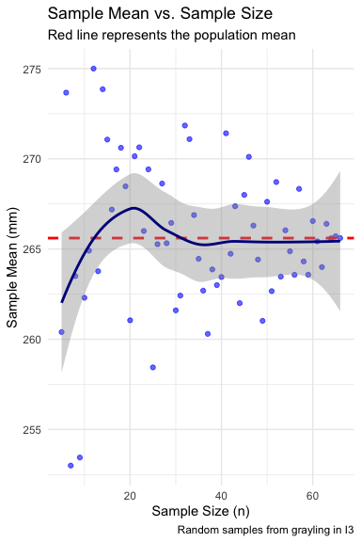

# **Lecture 4:** Standard Error of the Mean

The **standard error of the mean (SEM)** tells us how precise our sample mean is as an estimate of the population mean.

Standard Error Formula:

Where:

* is the sample standard deviation
* is the sample size

**Key properties:**

* SEM decreases as sample size increases
* SEM is used to construct confidence intervals
* SEM measures the precision of the sample mean

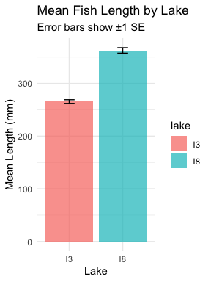

# **Lecture 4:** Confidence Intervals

A **confidence interval** is a range of values that is likely to contain the true population parameter.

95% Confidence Interval Formula:

$$\text{95\% CI}=\overset{‾}{y}±z⋅\frac{σ}{\sqrt{n}}$$

Where:

* ȳ is the sample mean
* 𝑛 is the sample size
* σ is the population standard deviation
* z is the z-value corresponding the probability of the CI

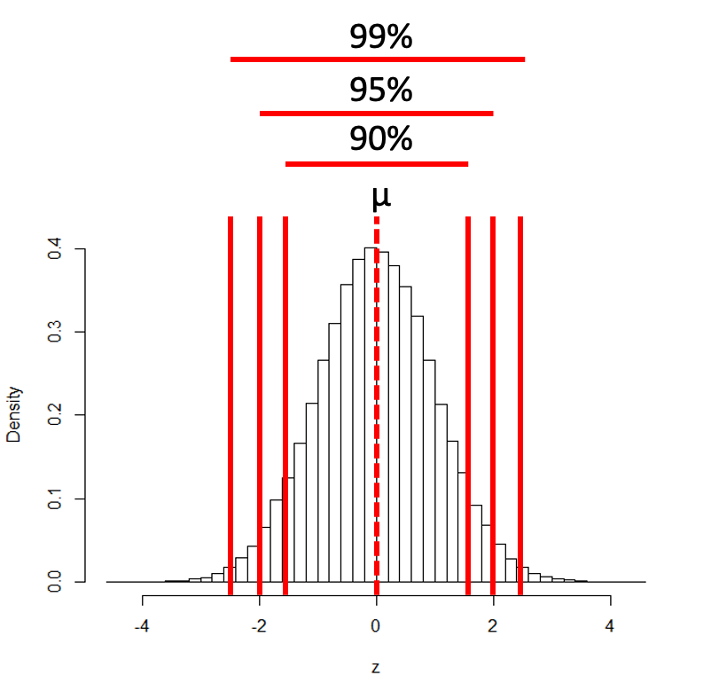

# **Lecture 4:** Confidence Intervals

A **confidence interval** is a range of values that is likely to contain the true population parameter.

**Interpretation:** If we were to take many samples and calculate the 95% CI for each, about 95% of these intervals would contain the true population mean.

**Common misinterpretation:** “There is a 95% probability that the true mean is in this interval.”

* Interpret 95% CI to mean:
  + Range of values that contains µ (population mean) with 95% probability
* More correctly:
  + If we took 100 samples from population
  + calculate a CI from each
  + 95 of the 100 CIs will contain the true population mean - µ

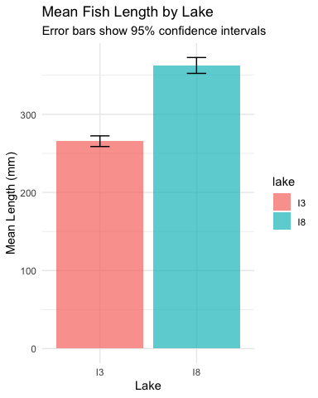

# **Lecture 4:** Compare the SE and CI plots

Lets compare what the two plots look like near each other

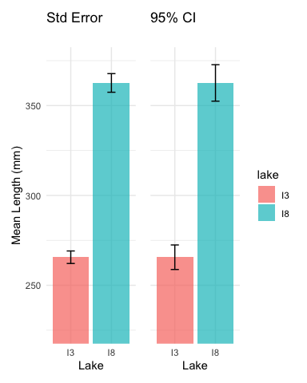

|  |
| --- |
| Practice Exercise 3: Calculating Standard Error and Confidence Intervals |
| Calculate the standard error and 95% confidence interval for the mean length of Arctic grayling in each lake.  # Calculate the standard error and confidence intervals by lake ci_results <- grayling_df %>%  group_by(lake) %>%  summarize(  mean_length = round(mean(total_length_mm, na.rm = TRUE), 2),  sd_length = sd(total_length_mm, na.rm = TRUE),  n = sum(!is.na(total_length_mm)),  se_length = round(sd_length / sqrt(n), 2),  ci = round(1.96 * se_length, 2),  ci_lower = round(mean_length - 1.96 * se_length, 2),  ci_upper = round(mean_length + 1.96 * se_length, 2),  .groups = "drop"  )  # Display the results ci_results  # A tibble: 2 × 8  lake mean_length sd_length n se_length ci ci_lower ci_upper  <chr> <dbl> <dbl> <int> <dbl> <dbl> <dbl> <dbl> 1 I3 266. 28.3 66 3.48 6.82 259. 272. 2 I8 363. 52.3 102 5.18 10.2 352. 373.  What do these confidence intervals tell us about the difference between lakes? |

# **Lecture 4:** Confidence intervals

In the more typical case DON’T know the population σ

* estimate it from the samples when don’t know the population σ
* and when sample size is <~30)
* can’t use the standard normal (z) distribution

*Instead, we use Student’s t distribution*

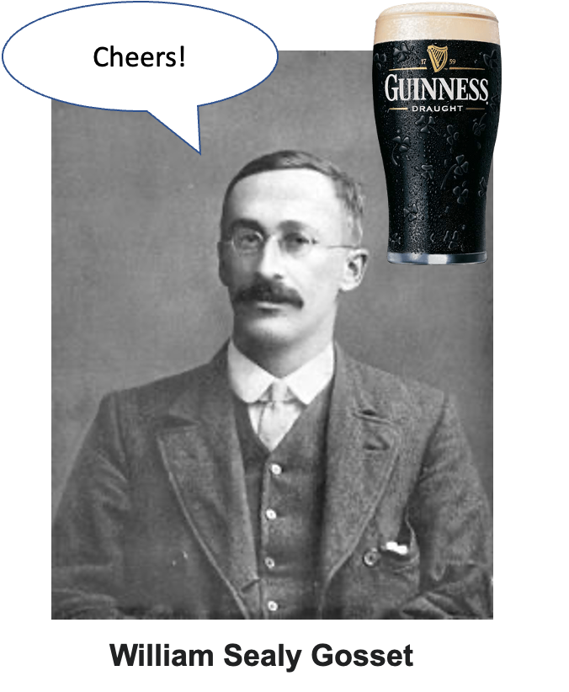

# **Lecture 4:** Understanding t-distribution

When sample sizes are small, the **t-distribution** is more appropriate than the normal distribution.

* Similar to normal distribution but with heavier tails
* Shape depends on **degrees of freedom** (df = n-1)
* With large df (>30), approaches the normal distribution
* Used for:
  + Small sample sizes
  + When population standard deviation is unknown
  + Calculating confidence intervals
  + Conducting t-tests

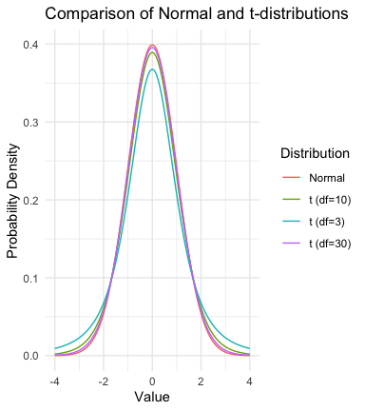

|  |
| --- |
| Practice Exercise 4: Using the t-distribution |
| Let’s compare confidence intervals using the normal approximation (z) versus the t-distribution for our fish data.  # Calculate CI using both z and t distributions for a smaller subset small_sample <- grayling_df %>%   filter(lake == "I3") %>%   slice_sample(n = 10)  # Calculate statistics sample_mean <- mean(small_sample$total_length_mm) sample_sd <- sd(small_sample$total_length_mm) sample_n <- nrow(small_sample) sample_se <- sample_sd / sqrt(sample_n)  # Calculate confidence intervals z_ci_lower <- sample_mean - 1.96 * sample_se z_ci_upper <- sample_mean + 1.96 * sample_se  # For t-distribution, get critical value for 95% CI with df = n-1 t_crit <- qt(0.975, df = sample_n - 1) t_ci_lower <- sample_mean - t_crit * sample_se t_ci_upper <- sample_mean + t_crit * sample_se  # Display results cat("Mean:", round(sample_mean, 1), "mm\n")  Mean: 255.3 mm  cat("Standard deviation:", round(sample_sd, 2), "mm\n")  Standard deviation: 26.26 mm  cat("Standard error:", round(sample_se, 2), "mm\n")  Standard error: 8.31 mm  cat("95% CI using z:", round(z_ci_lower, 1), "to", round(z_ci_upper, 1), "mm\n")  95% CI using z: 239 to 271.6 mm  cat("95% CI using t:", round(t_ci_lower, 1), "to", round(t_ci_upper, 1), "mm\n")  95% CI using t: 236.5 to 274.1 mm  cat("t critical value:", round(t_crit, 3), "vs z critical value: 1.96\n")  t critical value: 2.262 vs z critical value: 1.96 |

# Student’s t-distribution

To calculate CI for sample from “unknown” population:

$\text{CI}=\overset{‾}{y}±t⋅\frac{s}{\sqrt{n}}$

Where:

* ȳ is sample mean
* 𝑛 is sample size
* s is sample standard deviation
* t t-value corresponding the probability of the CI
* t in t-table for different degrees of freedom (n-1)

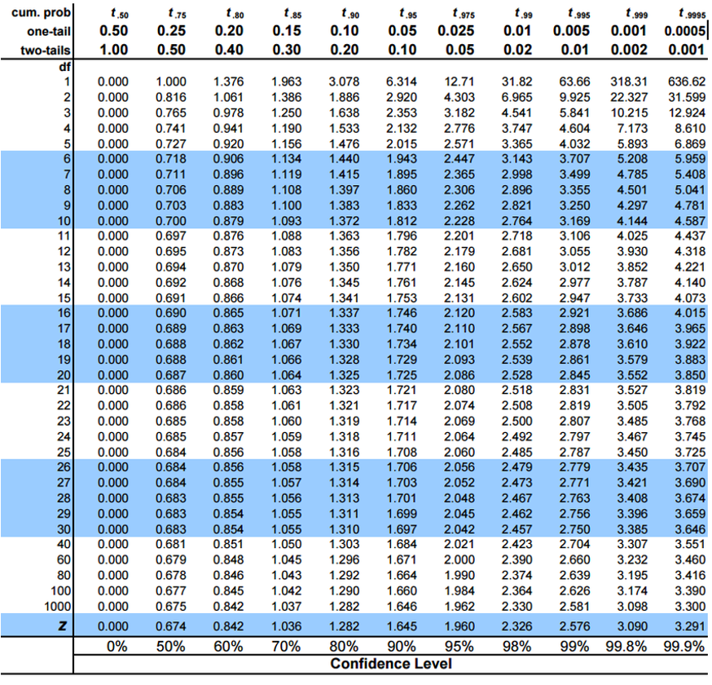

# **Lecture 5:** Student’s t-distribution

Here is a t-table

* Values of t that correspond to probabilities
* Probabilities listed along top
* Sample dfs are listed in the left-most column
* Probabilities are given for one-tailed and two-tailed “questions”



# **Lecture 5:** Student’s t-distribution

One-tailed questions: area of distribution left or (right) of a certain value

* n=20 (df=19) - 90% of the observations found left
* t= 1.328 (10% are outside)

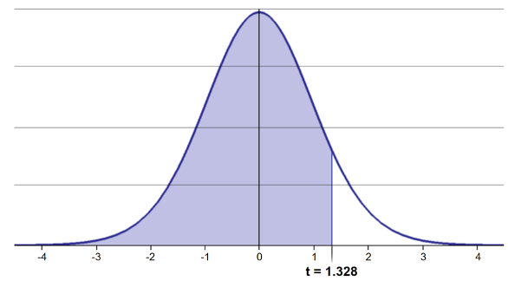

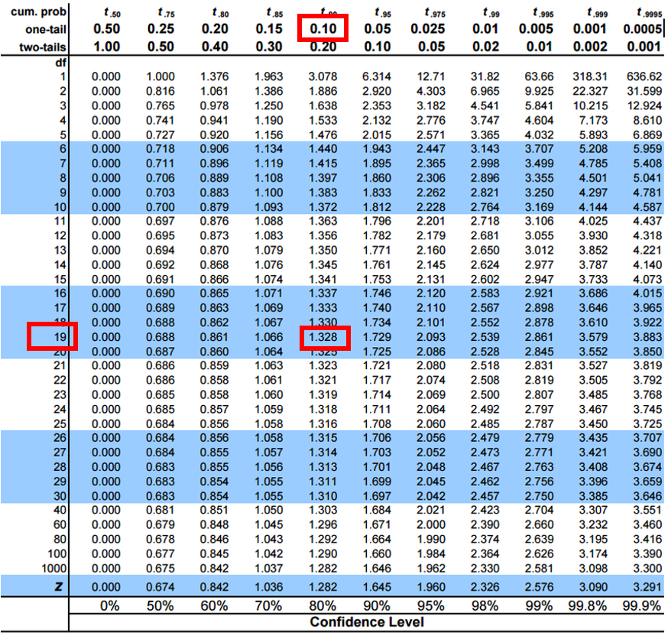

# **Lecture 5:** Student’s t-distribution

Two-tailed questions refer to area between certain values

* n= 20 (df=19), 90% of the observations are between
* t=-1.729 and t=1.729 (10% are outside)

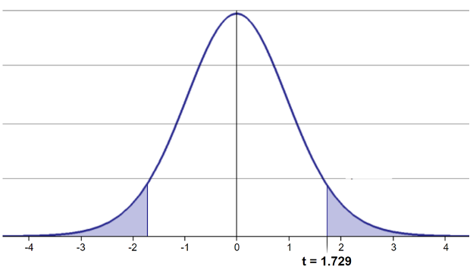

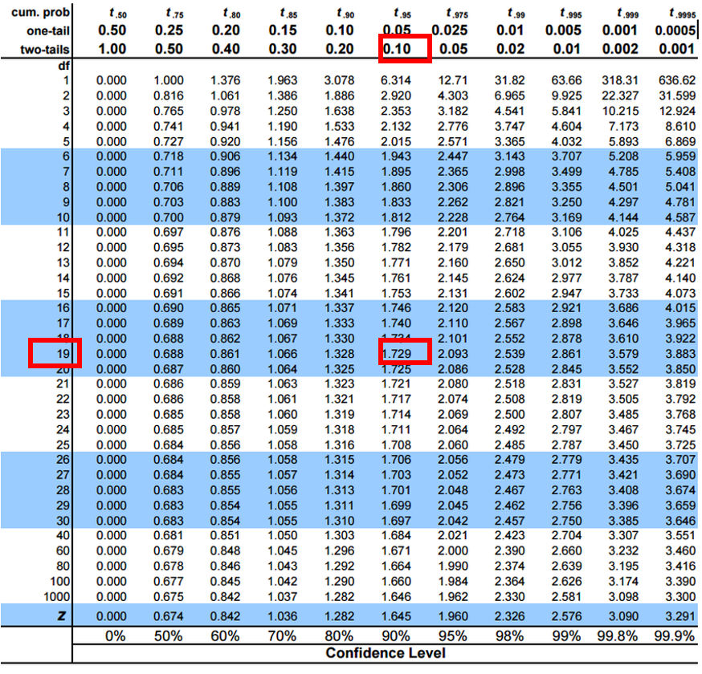

# **Lecture 5:** Student’s t-distribution

Let’s calculate CIs again:

Use two-sided test

* 95% CI Sample A: = 272.8 ± 2.262 * (37.81/(9^0.5)) = 1.650788
* The 95% CI is between 244.3 and 301.3
* “The 95% CI for the population mean from sample A is 272.8 ± 28.5”

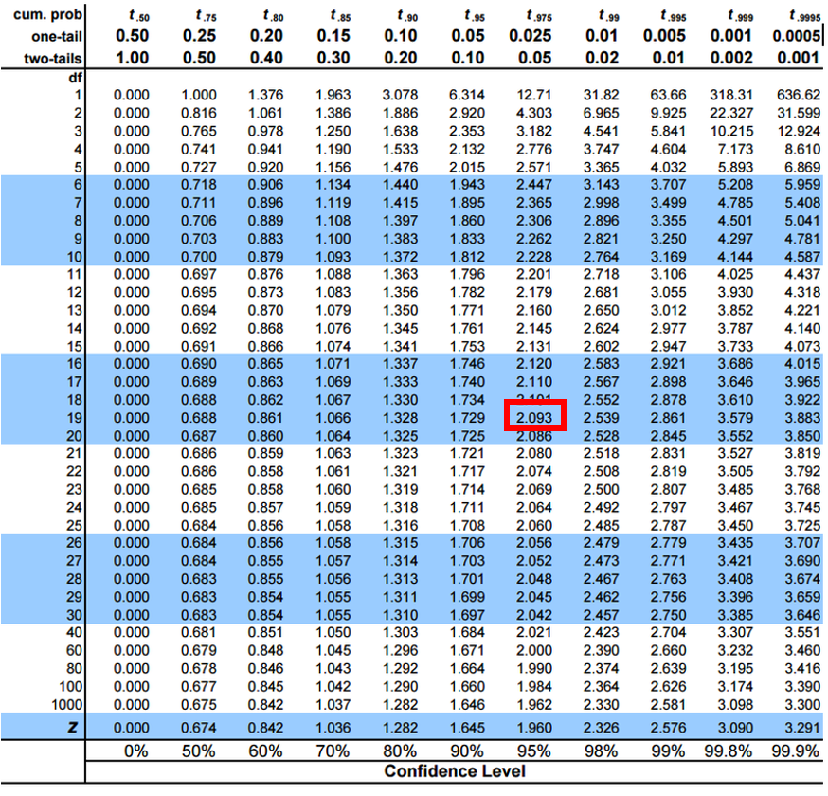

# **Lecture 4:** Intro to Hypothesis Testing

Hypothesis testing is a systematic way to evaluate research questions using data.

**Key components:**

1. **Null hypothesis (H₀)**: Typically assumes “no effect” or “no difference”
2. **Alternative hypothesis (Hₐ)**: The claim we’re trying to support
3. **Statistical test**: Method for evaluating evidence against H₀
4. **P-value**: Probability of observing our results (or more extreme) if H₀ is true
5. **Significance level (α)**: Threshold for rejecting H₀, typically 0.05

**Decision rule**: Reject H₀ if p-value < α

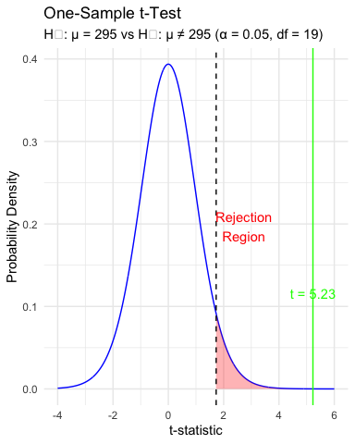

# **Lecture 4:** Intro to Hypothesis Testing

Hypothesis testing is a systematic way to evaluate research questions using data.

**Key components:**

1. **Null hypothesis (H₀)**: Typically assumes “no effect” or “no difference”
2. **Alternative hypothesis (Hₐ)**: The claim we’re trying to support
3. **Statistical test**: Method for evaluating evidence against H₀
4. **P-value**: Probability of observing our results (or more extreme) if H₀ is true
5. **Significance level (α)**: Threshold for rejecting H₀, typically 0.05

**Decision rule**: Reject H₀ if p-value < α

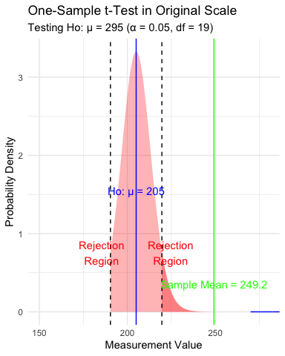

|  |
| --- |
| Practice Exercise 5: Lets practice a One-Sample t-Test |
| Let’s perform a one-sample t-test to determine if the mean fish length in Toolik Lake differs from 50 mm:  # get only lake I# i3_df <- grayling_df %>% filter(lake=="I3")  # what is the mean i3_mean <- mean(i3_df$total_length_mm, na.rm=TRUE) cat("Mean:", round(i3_mean, 1), "mm\n")  Mean: 265.6 mm  # Perform a one-sample t-test t_test_result <- t.test(i3_df$total_length_mm, mu = 260)  # View the test results t_test_result  One Sample t-test  data: i3_df$total_length_mm t = 1.6091, df = 65, p-value = 0.1124 alternative hypothesis: true mean is not equal to 260 95 percent confidence interval:  258.6481 272.5640 sample estimates: mean of x   265.6061  Interpret this test result by answering these questions:   1. What was the null hypothesis? 2. What was the alternative hypothesis? 3. What does the p-value tell us? 4. Should we reject or fail to reject the null hypothesis at α = 0.05? 5. What is the practical interpretation of this result for fish biologists? |

|  |
| --- |
| Practice Exercise 6: Formulating Hypotheses |
| For the following research questions about Arctic grayling, write the null and alternative hypotheses:   1. Are fish in Lake I8 longer than fish in Lake I3? 2. Is the mean length of Arctic grayling in these lakes different from 300 mm? 3. Is there a relationship between fish length and mass?   # Let's test one of these hypotheses: Are fish in Lake I8 longer than fish in Lake I3?  # Perform an independent t-test t_test_result <- t.test(total_length_mm ~ lake, data = grayling_df,   alternative = "less") # H₀: μ_I3 ≥ μ_I8, H₁: μ_I3 < μ_I8  # Display the results t_test_result  Welch Two Sample t-test  data: total_length_mm by lake t = -15.532, df = 161.63, p-value < 2.2e-16 alternative hypothesis: true difference in means between group I3 and group I8 is less than 0 95 percent confidence interval:  -Inf -86.66138 sample estimates: mean in group I3 mean in group I8   265.6061 362.5980  Based on this t-test, what can we conclude about the difference in fish length between the two lakes? |

# **Lecture 4:** Understanding P-values

A **p-value** is the probability of observing the sample result (or something more extreme) if the null hypothesis is true.

**Common interpretations:** - p < 0.05: Strong evidence against H₀ - 0.05 ≤ p < 0.10: Moderate evidence against H₀ - p ≥ 0.10: Insufficient evidence against H₀

**Common misinterpretations:** - p-value is NOT the probability that H₀ is true - p-value is NOT the probability that results occurred by chance - Statistical significance ≠ practical significance

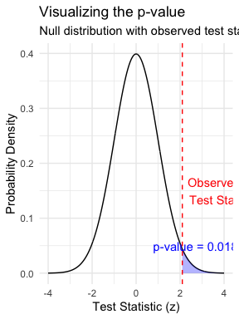

# **Lecture 4:** Type I and Type II Errors

When making decisions based on hypothesis tests, two types of errors can occur:

**Type I Error (False Positive)** - Rejecting H₀ when it’s actually true - Probability = α (significance level) - “Finding an effect that isn’t real”

**Type II Error (False Negative)** - Failing to reject H₀ when it’s actually false - Probability = β - “Missing an effect that is real”

**Statistical Power = 1 - β** - Probability of correctly rejecting a false H₀ - Increases with: - Larger sample size - Larger effect size - Lower variability - Higher α level

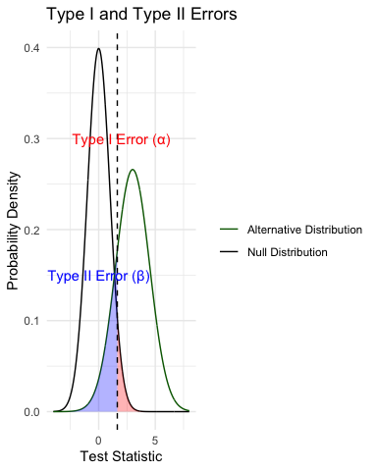

|  |
| --- |
| Practice Exercise 6: Interpreting P-values and Errors |
| Given the following scenarios, identify whether a Type I or Type II error might have occurred:   1. A researcher concludes that a new fishing regulation increased grayling size, when in fact it had no effect. 2. A study fails to detect a real decline in grayling population due to warming water, concluding there was no effect. 3. Let’s calculate the power of our t-test to detect a 30 mm difference in length between lakes:   # Calculate power for detecting a 30 mm difference # First determine parameters lake_I3 <- grayling_df %>% filter(lake == "I3") lake_I8 <- grayling_df %>% filter(lake == "I8")   n1 <- nrow(lake_I3) n2 <- nrow(lake_I8) sd_pooled <- sqrt((var(lake_I3$total_length_mm) * (n1-1) +   var(lake_I8$total_length_mm) * (n2-1)) /   (n1 + n2 - 2))  # Calculate power effect_size <- 30 / sd_pooled # Cohen's d df <- n1 + n2 - 2 alpha <- 0.05 power <- power.t.test(n = min(n1, n2),   delta = effect_size,  sd = 1, # Using standardized effect size  sig.level = alpha,  type = "two.sample",  alternative = "two.sided")  # Display results power  Two-sample t test power calculation    n = 66  delta = 0.6741298  sd = 1  sig.level = 0.05  power = 0.9702076  alternative = two.sided  NOTE: n is number in *each* group |

# **Lecture 4:** Summary

**Key concepts covered:**

1. **Probability distributions** model random phenomena
   * Normal distribution is especially important
   * Z-scores standardize measurements
2. **Standard error** measures precision of estimates
   * Decreases with larger sample sizes
   * Used to construct confidence intervals
3. **Confidence intervals** express uncertainty
   * Provide plausible range for parameters
   * 95% CI: mean ± 1.96 × SE
4. **Hypothesis testing** evaluates claims
   * Null vs. alternative hypotheses
   * P-values quantify evidence against H₀
   * Consider both statistical and practical significance

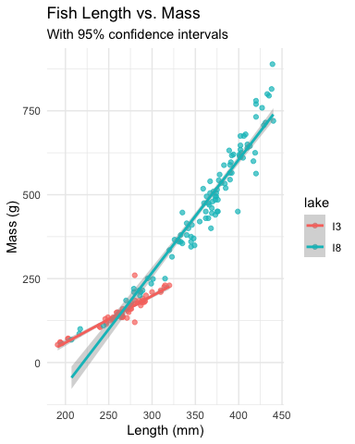

|  |
| --- |
| Final Exercise: Comprehensive Analysis |
| Now that we’ve covered the key concepts, let’s perform a complete analysis of the Arctic grayling data:  # Comprehensive analysis of Arctic grayling data # 1. Data visualization length_boxplot <- grayling_df %>%  ggplot(aes(x = lake, y = total_length_mm, fill = lake)) +  geom_boxplot() +  labs(title = "Fish Length by Lake",  x = "Lake",  y = "Length (mm)") +  theme_minimal()  # 2. Compare means with t-test length_ttest <- t.test(total_length_mm ~ lake, data = grayling_df)  # 3. Length-mass relationship length_mass_model <- lm(mass_g ~ total_length_mm * lake, data = grayling_df) model_summary <- summary(length_mass_model)  # 4. Display results length_boxplot    length_ttest  Welch Two Sample t-test  data: total_length_mm by lake t = -15.532, df = 161.63, p-value < 2.2e-16 alternative hypothesis: true difference in means between group I3 and group I8 is not equal to 0 95 percent confidence interval:  -109.32342 -84.66053 sample estimates: mean in group I3 mean in group I8   265.6061 362.5980  model_summary  Call: lm(formula = mass_g ~ total_length_mm * lake, data = grayling_df)  Residuals:  Min 1Q Median 3Q Max  -151.223 -14.839 -0.764 10.670 153.130   Coefficients:  Estimate Std. Error t value Pr(>|t|)  (Intercept) -219.3313 47.9087 -4.578 9.30e-06 *** total_length_mm 1.3924 0.1794 7.763 8.88e-13 *** lakeI8 -522.5506 56.5882 -9.234 < 2e-16 *** total_length_mm:lakeI8 1.9738 0.1972 10.009 < 2e-16 *** --- Signif. codes: 0 '***' 0.001 '**' 0.01 '*' 0.05 '.' 0.1 ' ' 1  Residual standard error: 40.93 on 162 degrees of freedom  (2 observations deleted due to missingness) Multiple R-squared: 0.9644, Adjusted R-squared: 0.9637  F-statistic: 1461 on 3 and 162 DF, p-value: < 2.2e-16  # 5. Calculate 95% confidence intervals for each lake ci_results <- grayling_df %>%  group_by(lake) %>%  summarize(  mean_length = mean(total_length_mm, na.rm = TRUE),  sd_length = sd(total_length_mm, na.rm = TRUE),  n = sum(!is.na(total_length_mm)),  se_length = sd_length / sqrt(n),  t_crit = qt(0.975, df = n - 1),  margin_error = t_crit * se_length,  ci_lower = mean_length - margin_error,  ci_upper = mean_length + margin_error,  .groups = "drop"  )  # Display confidence intervals ci_results  # A tibble: 2 × 9  lake mean_length sd_length n se_length t_crit margin_error ci_lower  <chr> <dbl> <dbl> <int> <dbl> <dbl> <dbl> <dbl> 1 I3 266. 28.3 66 3.48 2.00 6.96 259. 2 I8 363. 52.3 102 5.18 1.98 10.3 352. # ℹ 1 more variable: ci_upper <dbl>  # 6. Visualize regression with confidence intervals regression_plot <- grayling_df %>%  ggplot(aes(x = total_length_mm, y = mass_g, color = lake)) +  geom_point(alpha = 0.7) +  geom_smooth(method = "lm", se = TRUE) +  labs(title = "Length-Mass Relationship by Lake",  x = "Length (mm)",  y = "Mass (g)") +  theme_minimal()  regression_plot    Based on this analysis: 1. Are there significant differences in fish length between the two lakes? 2. How does the length-mass relationship differ between lakes? 3. What conclusions can you draw about Arctic grayling in these two lakes? |

# **Lecture 4:** Error Bars and Their Interpretation

Error bars are graphical representations of the variability of data that show:

* The **precision** of a measurement
* The **uncertainty** around an estimate
* A **confidence interval** for a parameter

Common types of error bars: 1. **Standard Error (SE)**: Shows precision of the mean 2. **Standard Deviation (SD)**: Shows variability in the data 3. **Confidence Interval (CI)**: Shows plausible range for parameter

When interpreting graphs: - Always check what the error bars represent - Non-overlapping 95% CI bars suggest statistically significant differences - Error bars help assess both statistical and practical significance

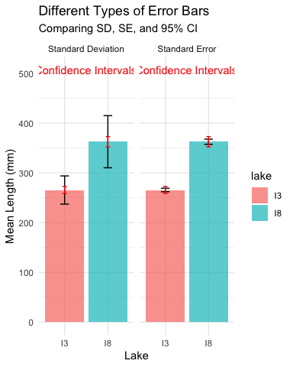

# **Lecture 4:** Sampling and Pseudoreplication

**Pseudoreplication** occurs when measurements that are not independent are analyzed as if they were independent.

* A critical consideration in experimental design
* Results in underestimated standard errors and confidence intervals
* Leads to inflated Type I error rates (false positives)

**Examples of pseudoreplication:** - Measuring the same individual multiple times - Treating multiple fish from the same tank as independent - Using multiple data points from a single site

**How to avoid pseudoreplication:** - Identify the true experimental unit - Use appropriate statistical techniques (e.g., mixed models) - Be clear about the level of replication

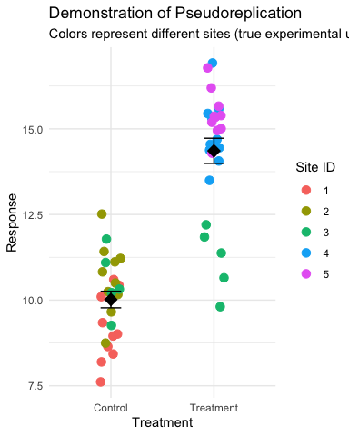

# **Lecture 4:** Practical Applications in Fish Biology

The statistical concepts we’ve covered today are essential for fisheries biologists and ecologists:

* **Z-scores** help identify unusual fish sizes in a population
* **Standard error** quantifies uncertainty in growth rate estimates
* **Confidence intervals** provide plausible ranges for population parameters
* **Hypothesis testing** evaluates effects of management practices
* **P-values** determine significance of environmental impacts

**Real-world applications:** - Assessing population health and structure - Evaluating effectiveness of fishing regulations - Quantifying relationships between fish size and habitat variables - Predicting impacts of climate change on fish populations - Designing effective conservation strategies

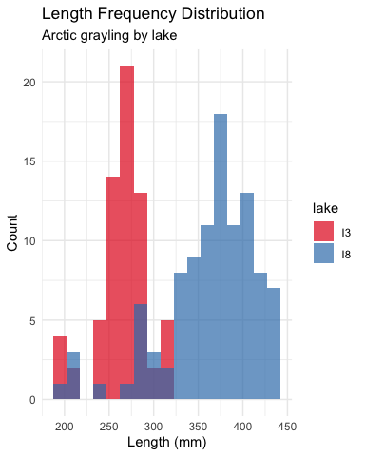

# **Lecture 4:** Next Steps in Statistical Analysis

In future lectures, we’ll explore:

* One-sample and two-sample t-tests
* Analysis of variance (ANOVA)
* Linear regression and correlation
* Chi-square tests
* Non-parametric methods
* Multiple regression and model selection
* Mixed effects models

Each method builds on the statistical foundation we’ve established today, applying probability concepts to make inferences from data.

|  |
| --- |
| Learning Resources |
| * Practice problems in the textbook (Chapter 4 & 5) * Online resources:   + Khan Academy: Probability and Statistics   + StatQuest with Josh Starmer (YouTube channel)   + R for Data Science (r4ds.had.co.nz) * Office hours: Wednesdays 2-4pm |